**Indian Trade Analysis and Forecasting**

**Project Report**

**Akarsh Somani (162) and Gaurav Misra (172)**

The data is monthly data from Jan 2006 to Sept 2019.The value is in million US Dollar $ and the stats are as follows–

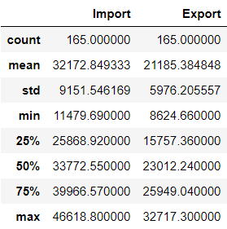

After trying several forecasting models we reached to the below accuracy. The RMSE is calculated for 12 months forecast for which we have the existing data –

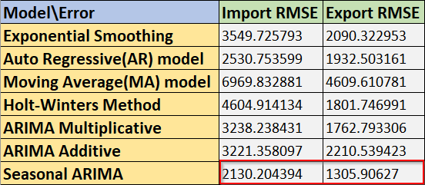

With the Best model as Seasonal ARIMA. One more reason for this error is because we have only 165 data points (because it’s monthly data) out of which we are using 153 for training the forecasting model and 12 for prediction testing. So, with such small data set the RMSE is predictable.

**Plots for all the Forecasting methods are as follows –**

1. Exponential Smoothing - 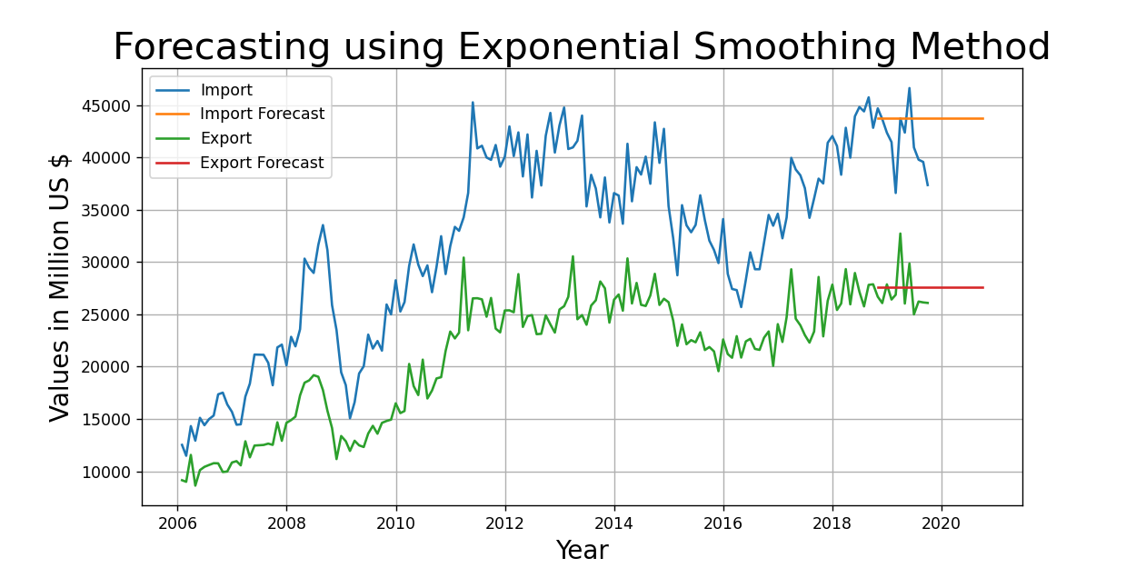
2. Auto-Regressive (AR) Model - 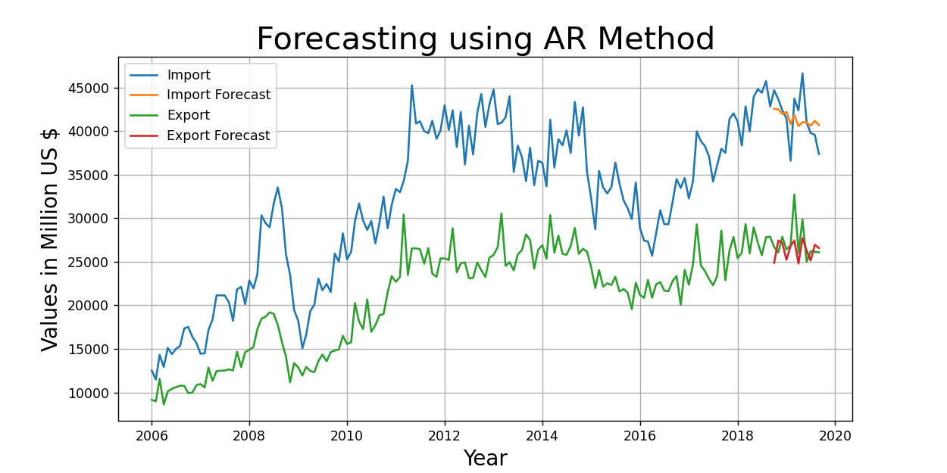
3. Moving Average (MA) Model - 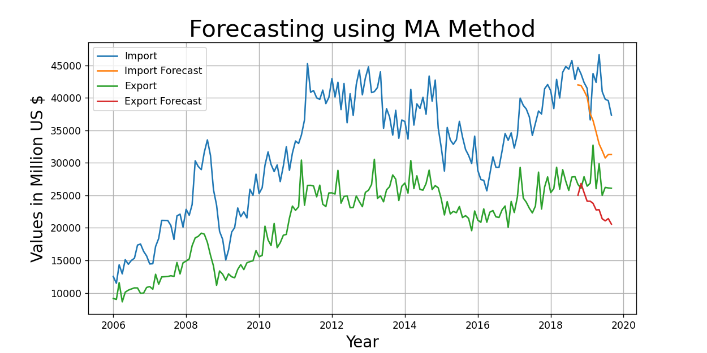
4. Holt-Winters Method - 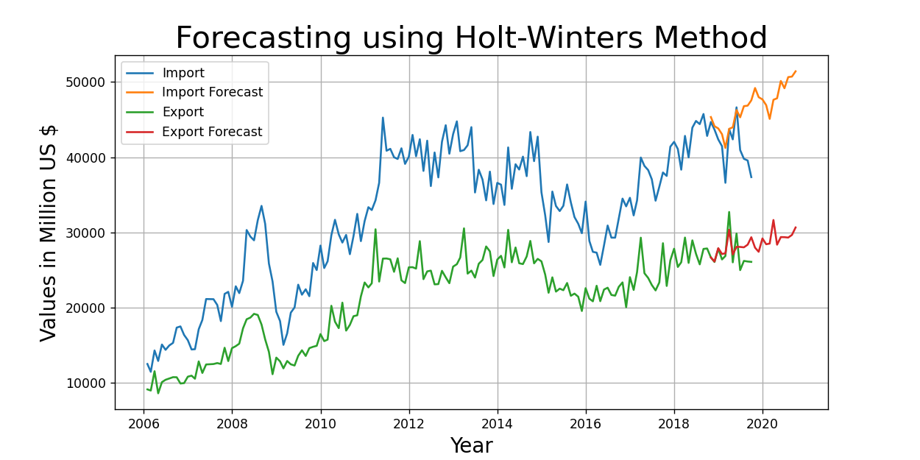
5. ARIMA Multiplicative – 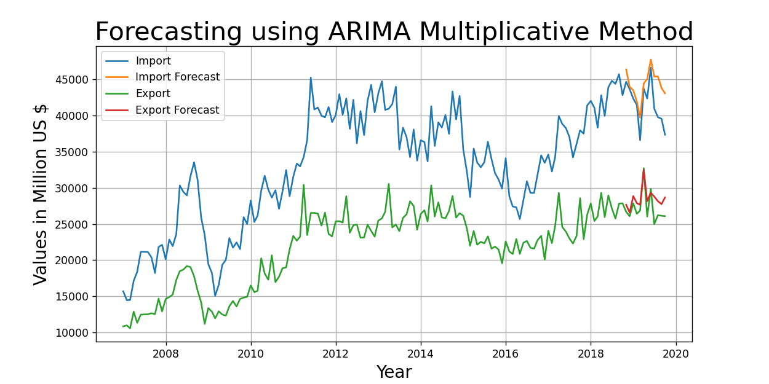
6. ARIMA Additive – 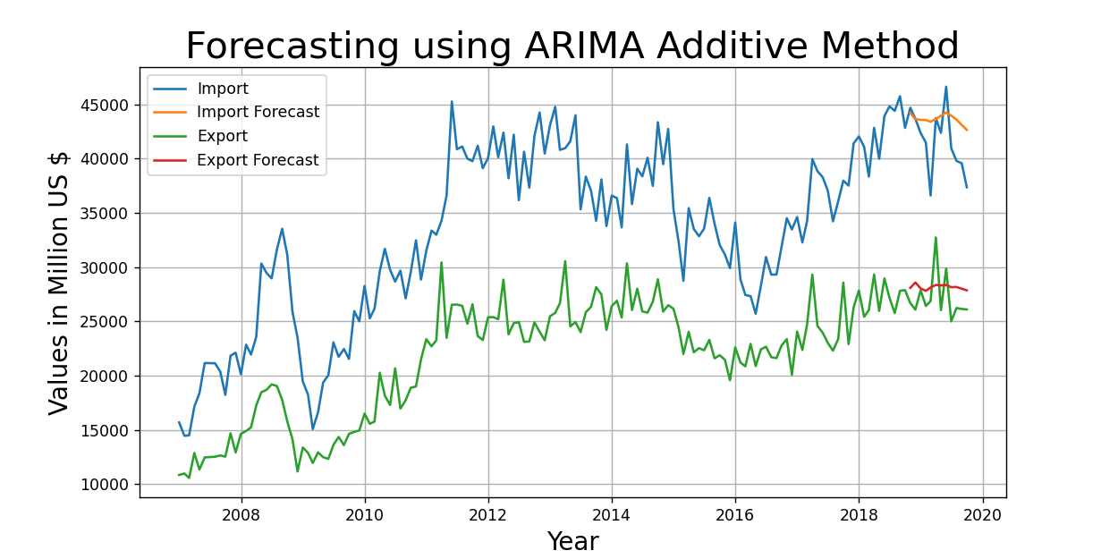
7. Seasonal ARIMA – The Best Model